26.54: a) 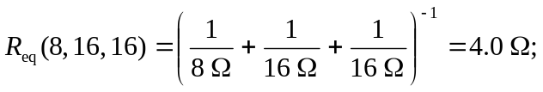
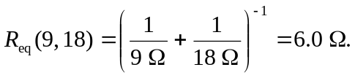
So the circuit is equivalent to the one shown below. Thus:
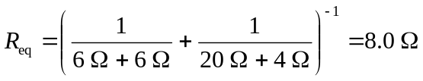
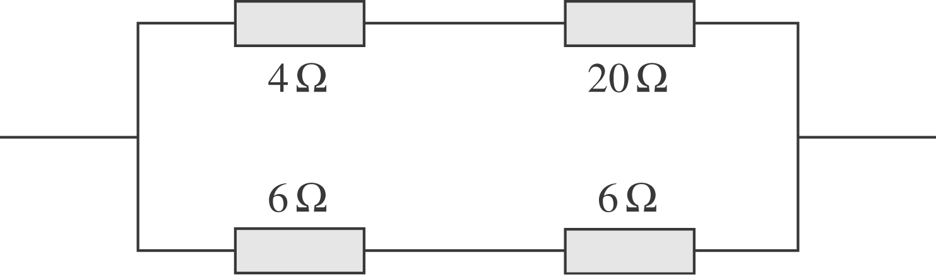
b) If the current through the 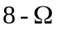 resistor is 2.4 A, then the top branch current is But the bottom branch current is twice that of the top, since its resistance is half. Therefore the potential of point a relative to point

